Art of Centuries: Virat Kohli's 71 Masterstrokes Visualized with Tableau

Virat Kohli is an Indian cricketer widely regarded as one of the modern era's greatest batsmen. Born on November 5, 1988, in Delhi, India, Kohli has been a prominent figure in international cricket. He has represented the Indian national team as a prolific right-handed batsman and has achieved numerous records and accolades throughout his career. Kohli is known for his exceptional batting skills, remarkable consistency, and fierce competitiveness. He has been the captain of the Indian cricket team and has led the team to numerous victories. His aggressive style of play and dedication to fitness have made him a role model for aspiring cricketers around the world. Kohli's contributions to Indian cricket and his outstanding batting performances have earned him a special place in the sport's history.

# Technical Architecture:

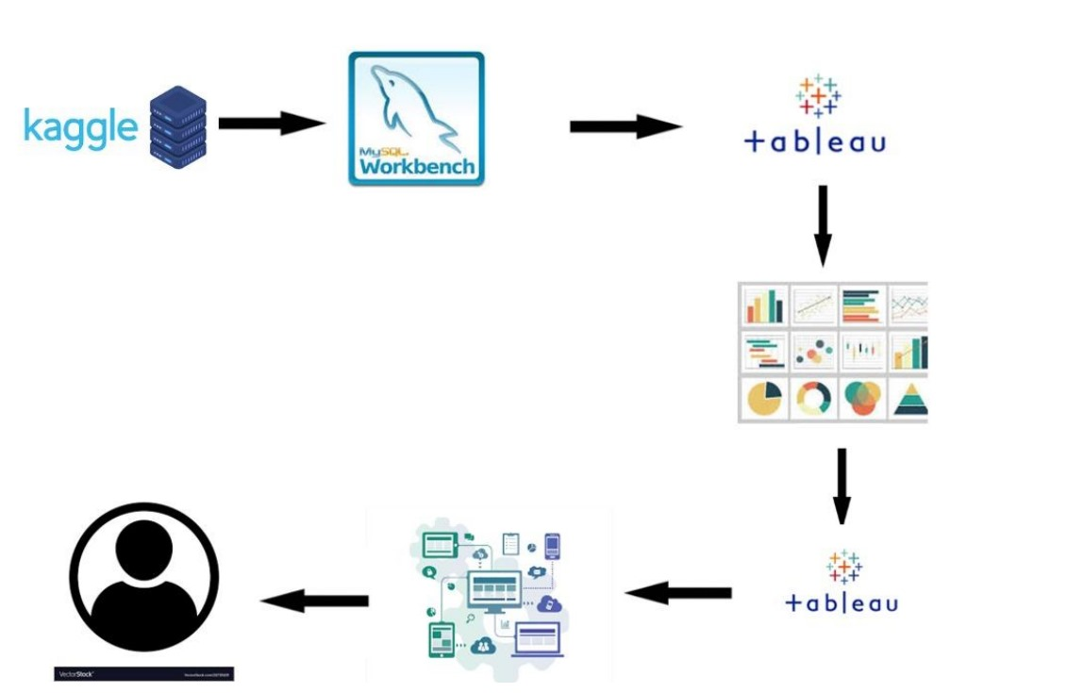

**Project Flow**

To accomplish this, we have to complete all the activities listed below,

* **Define Problem / Problem Understanding**
* Specify the business problem
* Business requirements
* Literature Survey
* Social or Business Impact.
* **Data Collection & Extraction from Database**
* Collect the dataset,
* Storing Data in DB
* Perform SQL Operations
* Connect DB with Tableau
* **Data Preparation**
* Prepare the Data for Visualization
* **Data Visualizations**
  + No of Unique Visualizations
* **Dashboard**
  + Responsive and Design of Dashboard
* **Story**
  + No of Scenes of Story.
* **Performance Testing**
  + Amount of Data Rendered to DB.
* **Web Integration**
  + Dashboard and Story embed with Flask.
* **Project Demonstration & Documentation**
  + Record explanation Video for project end to end solution.
  + Project Documentation-Step by step project development procedure.

# Milestone 1: Define Problem / Problem Understanding Activity 1: Specify the business problem

# Solution architecture is a complex process – with many sub-processes – that bridges the gap between business problems and technology solutions. Its goals are to:

# Find the best tech solution to solve existing business problems.

# Describe the structure, characteristics, behavior, and other aspects of the software to project stakeholders.

# Define features, development phases, and solution requirements.

# Provide specifications according to which the solution is defined, managed, and delivered.

# Activity 2: Business requirements

The project focuses on the remarkable career and achievements of the renowned Indian cricketer, Virat Kohli. Often hailed as one of the finest batsmen in the history of cricket, he represents the Royal Challengers Bangalore in the Indian Premier League (IPL) and plays for Delhi in domestic cricket. His extraordinary records and contributions to the sport make him a legendary figure in the world of cricket.

# Activity 3: Literature Survey

# A literature survey is a method employed to investigate and analyze existing literature and studies pertaining to the assessment of Virat Kohli's performance. In the context of evaluating Virat Kohli's records, a literature survey would entail a comprehensive review of articles and publications specifically centered around Virat Kohli. This survey may encompass diverse sources, including reports from the Board of Control for Cricket in India (BCCI) and online articles. The primary objective of this literature survey is to pinpoint the key performance indicators (KPIs) and metrics that are commonly utilized to gauge Virat Kohli's cricketing achievements.

# Activity 4: Social Impact

**Social Impact**: Making Informative about Virat Kohil Career

# Milestone 2: Data Collection & Extraction from Database

Data collection and extraction from a database involve gathering specific data from a database, transforming it if necessary, and exporting it for analysis or other purposes. This process typically includes defining data requirements, accessing the database, querying, or extracting data, transforming the data, and exporting it in a suitable format. It's crucial for tasks like analysis, reporting, and decision-making.

**Activity 1: Collect the dataset**

Please use the link to download the dataset

**<https://www.kaggle.com/datasets/gauravtopre/virat-kohlis-71-centuries> Activity 1.1: Understand the data**

Data contains all the meta information regarding the columns described in the CSV file. we have provided CSV file:

**Columns:**

**Score Batting Order Strike Rate Venue Column1 Result Format**

**Man of the Match Captain**

**Against Inn.**

**H/A**

**Activity 2: Storing Data in DB & Perform SQL Operations**

**<https://drive.google.com/file/d/1JwaCWE1aJ-421V1cfM4dIU-zZCot22xT/view?usp=sharing>**

**Activity 3:** Importing Data from my SQL to Tableau.

**<https://drive.google.com/file/d/1bk16j7kekTsyYv1pMlNTIF_o_JrW-dF3/view?usp=sharing>**

**Milestone 3: Data Preparation**

**Activity 1: Prepare the Data for Visualization**

# Data Preparation for Visualization: In some cases, data may not be in an ideal format for visualization, necessitating data transformation to ensure it's in a suitable format. Data preparation involves tasks such as data cleaning, handling null values, and addressing missing data. These processes enhance data clarity, making it more understandable and facilitating the creation of effective visualizations.

# Milestone 4: Data Visualization

Activity 1: Understanding Data Visualization

Data visualization is the process of transforming data into visual elements to facilitate comprehension and exploration. Its core aim is to simplify intricate data sets, rendering them more accessible, user-friendly, and interpretable. By employing graphical tools such as charts, graphs, and maps, data visualization enables individuals to swiftly discern patterns, trends, and exceptional data points, empowering them to make informed decisions and gain deeper insights from the data.

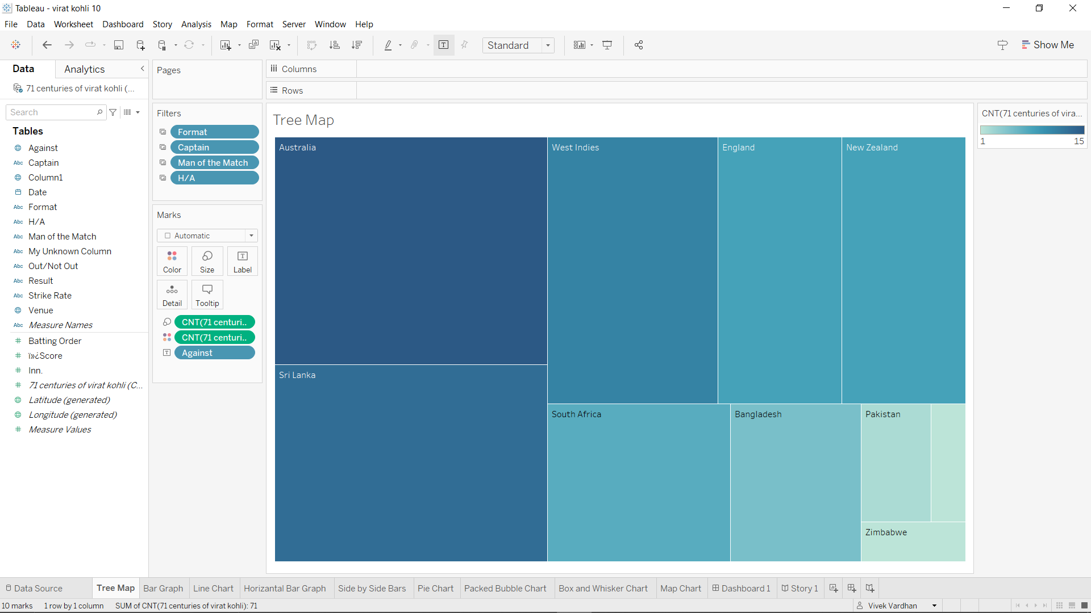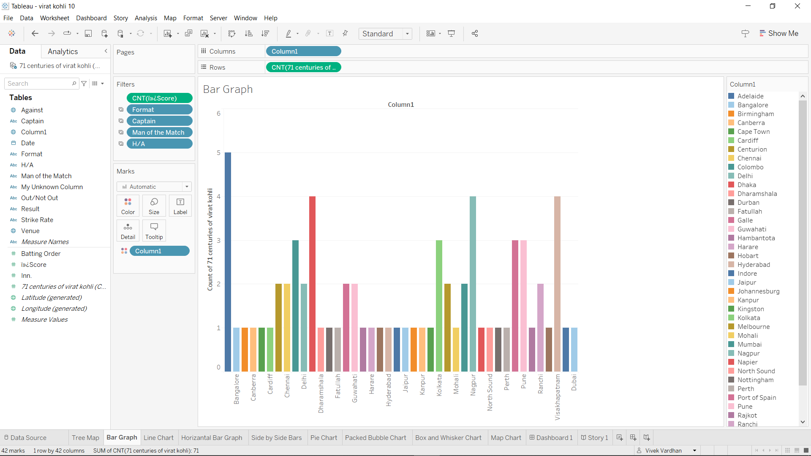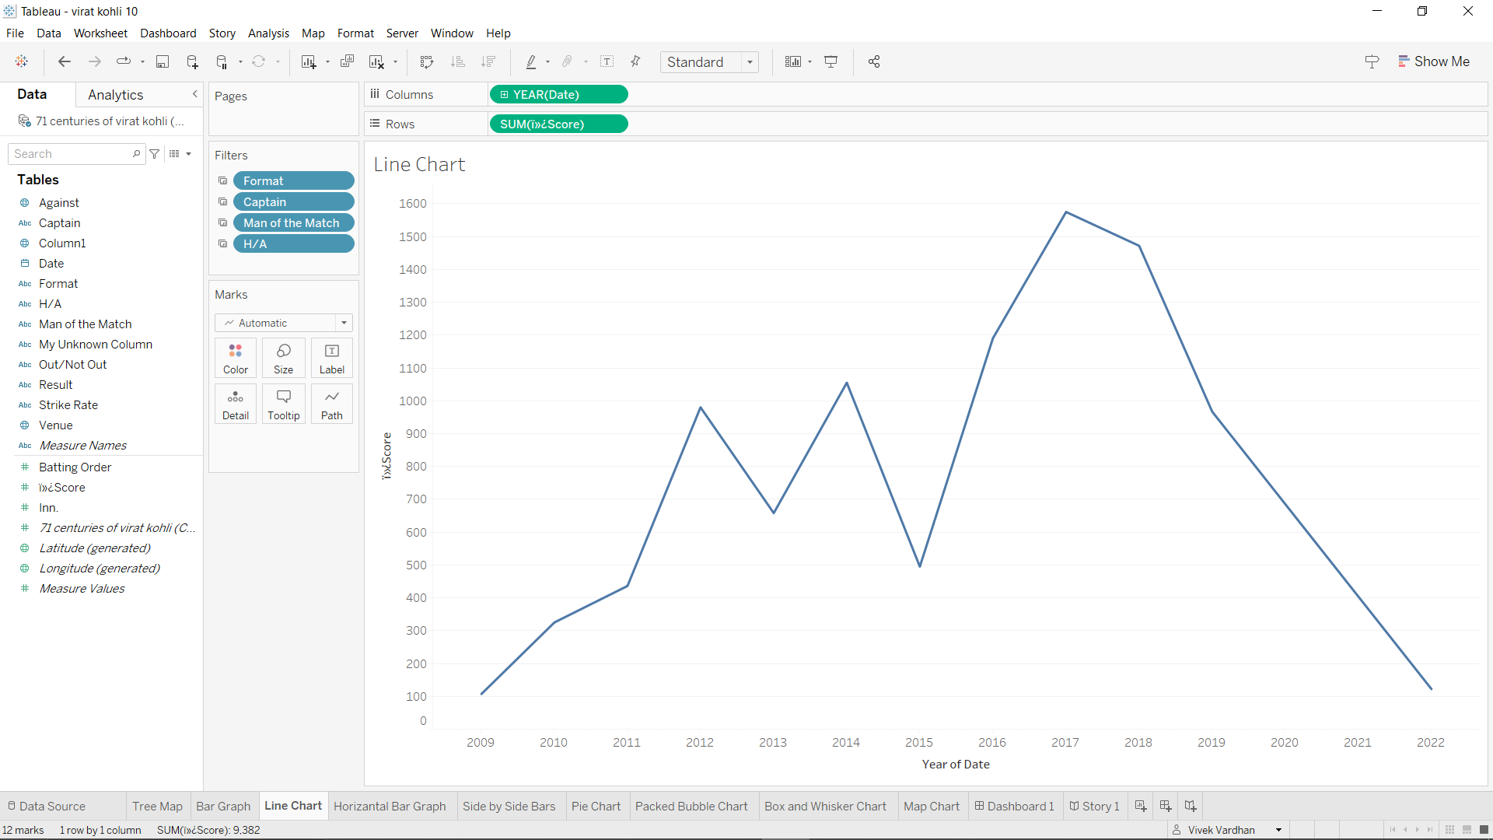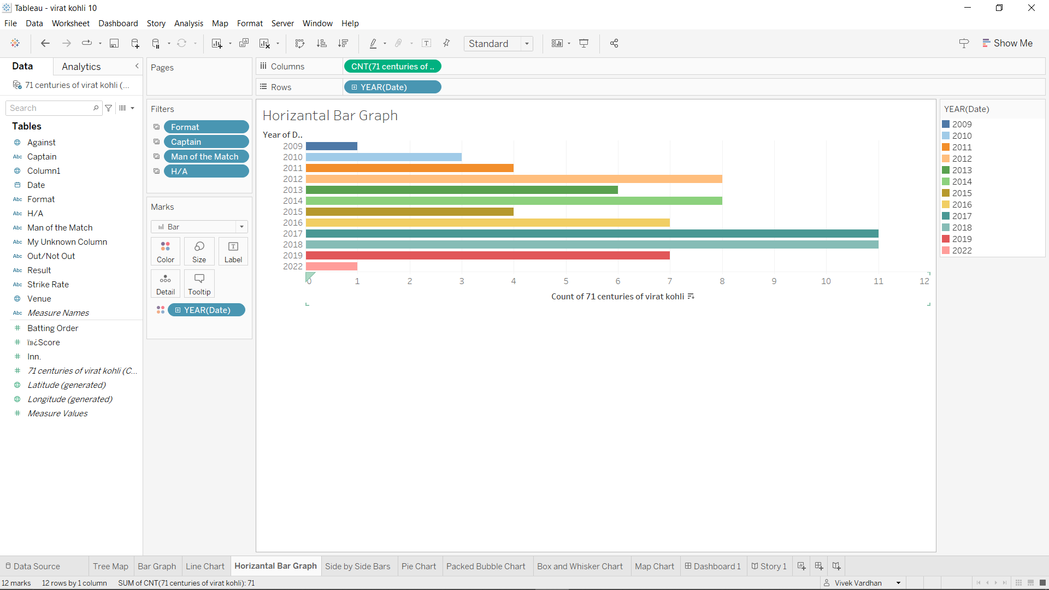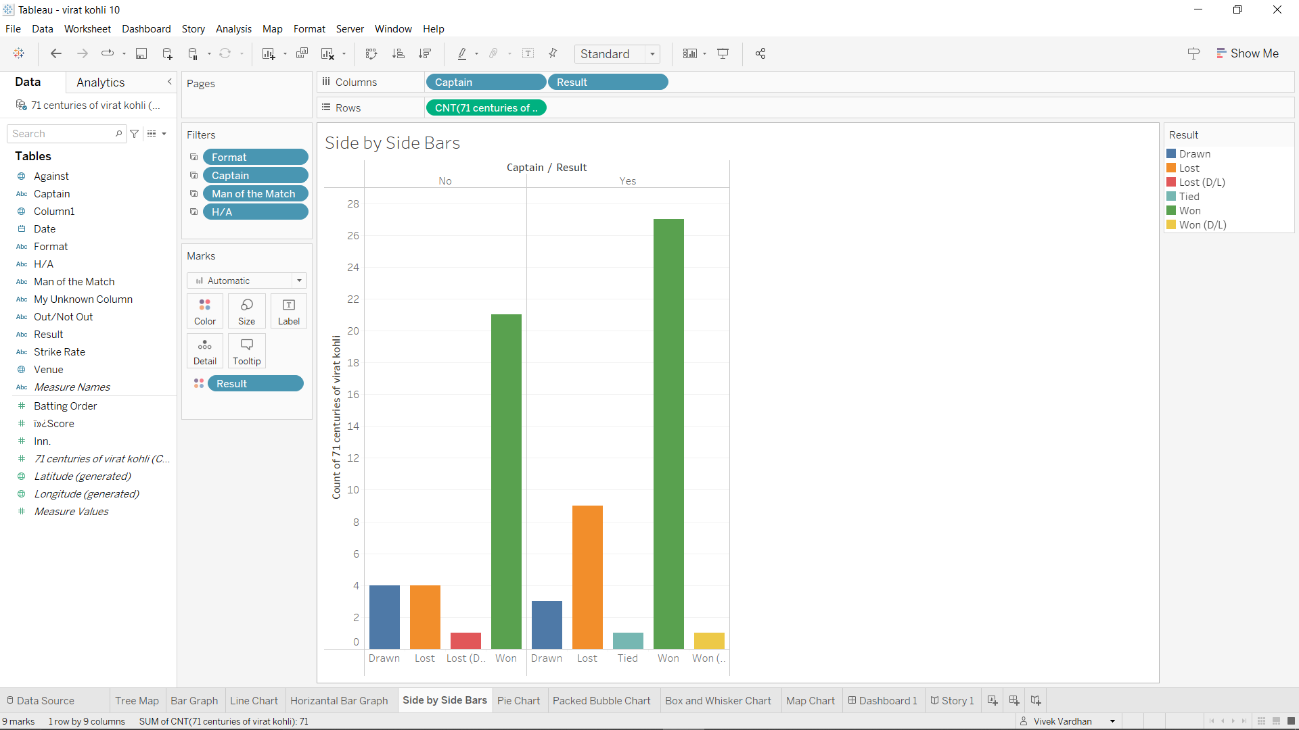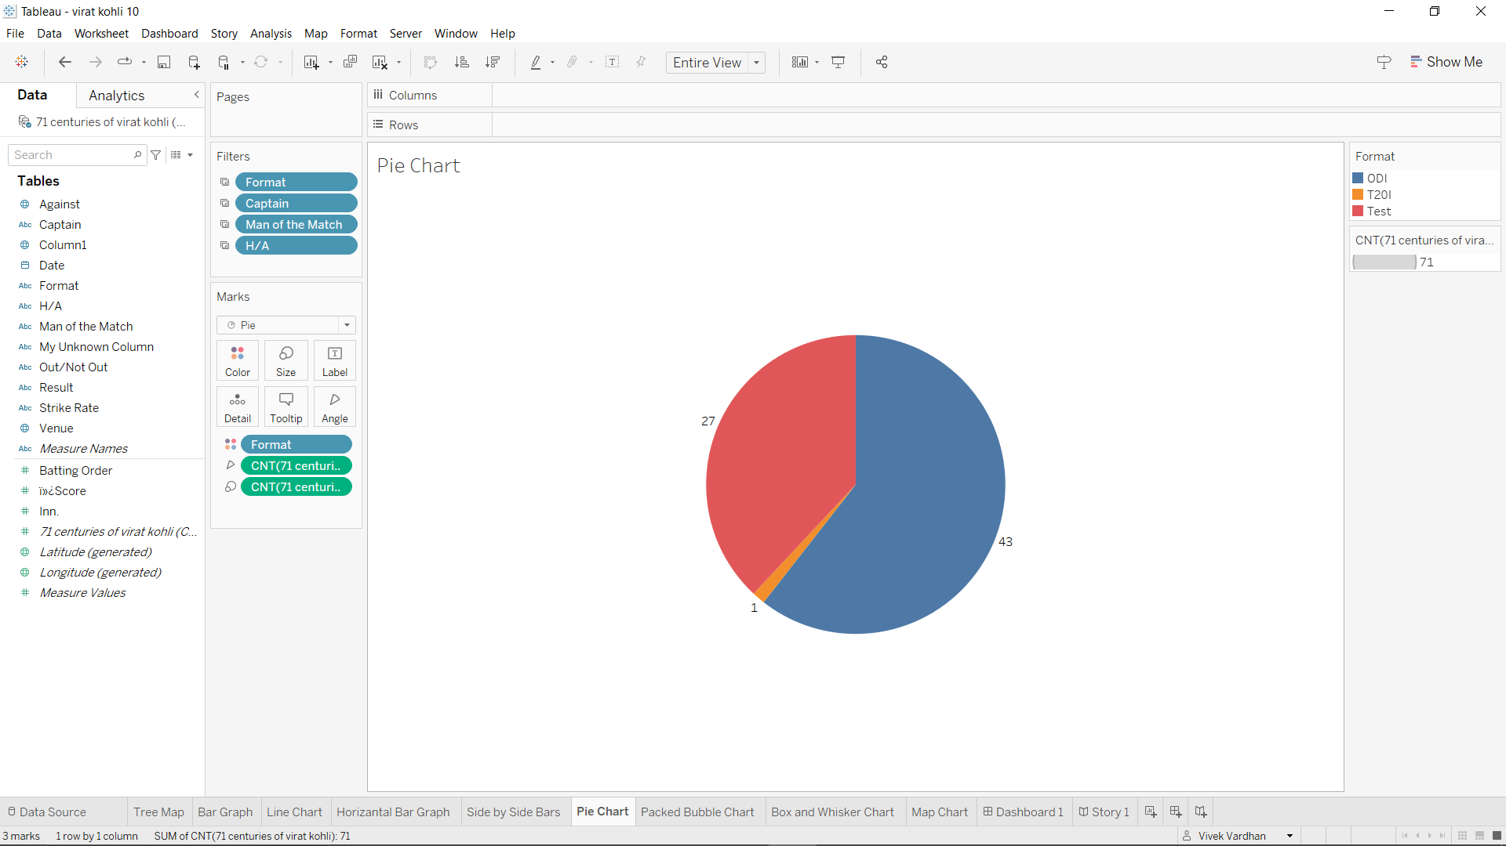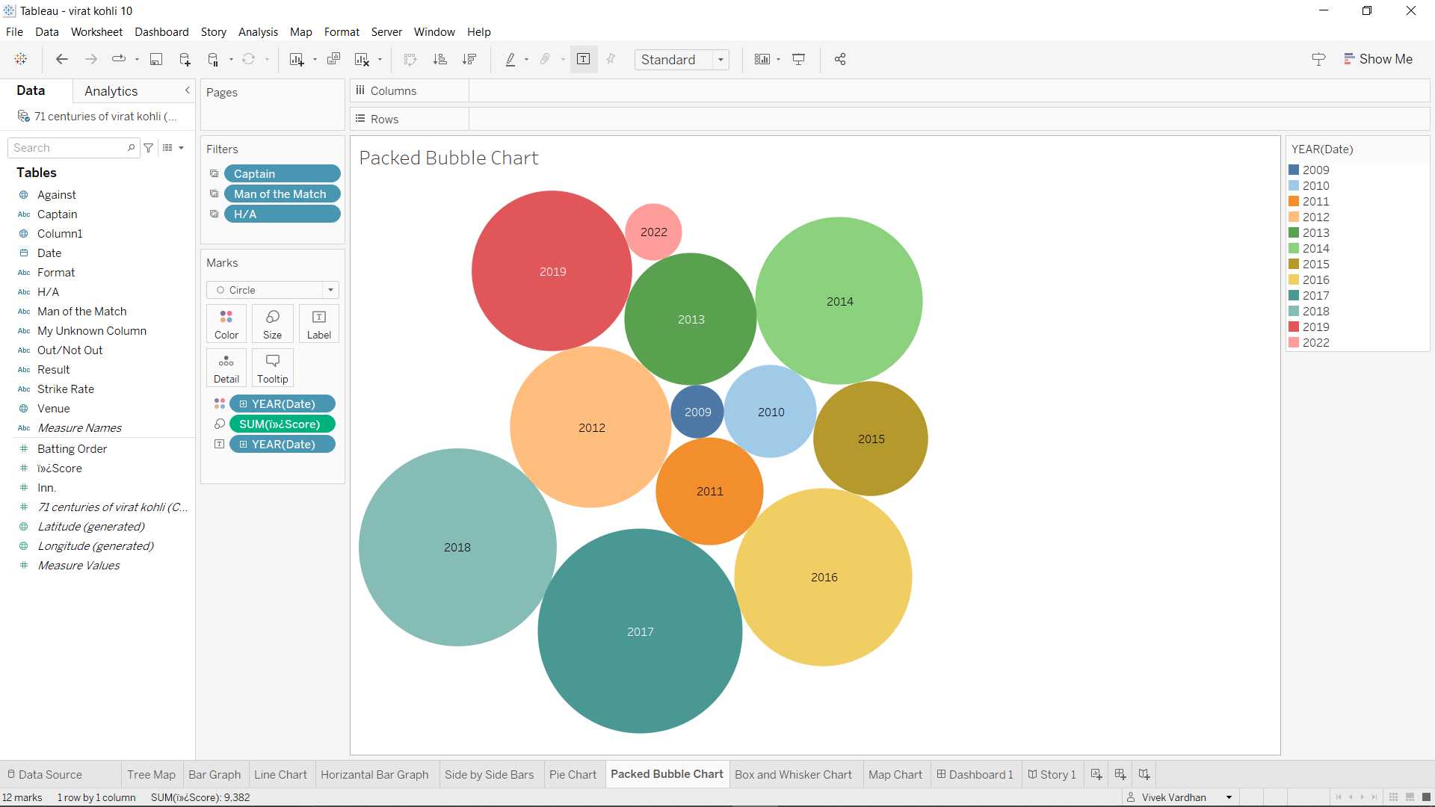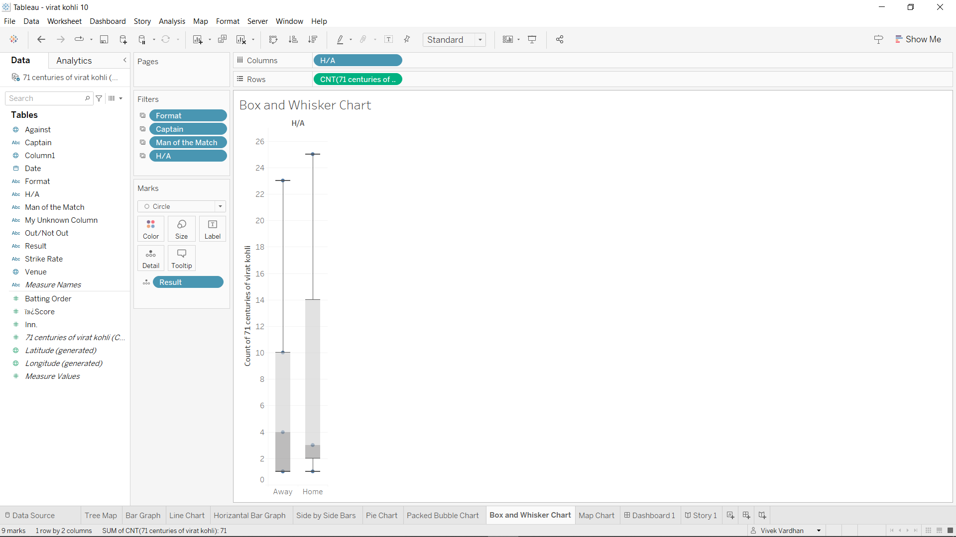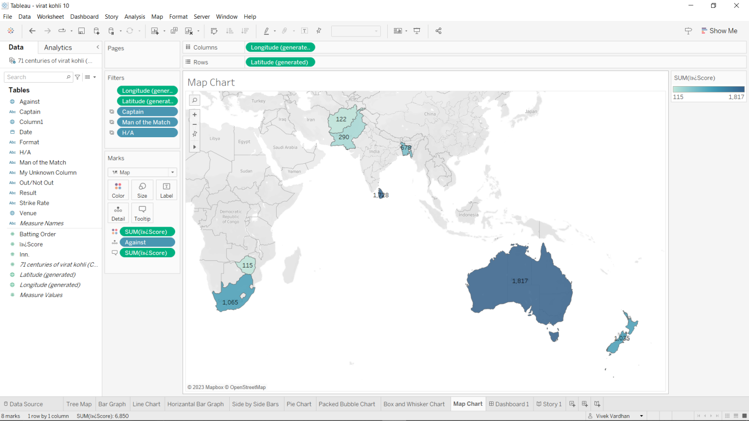

# Milestone 5: Dashboard

A dashboard is a user-friendly graphical interface that presents information and data in a well-organized, easy-to-read format. Dashboards are commonly employed for real-time data monitoring and analysis, often tailored to specific purposes or use cases. They find applications across diverse sectors including business, finance, manufacturing, healthcare, and many others. Dashboards serve to track key performance indicators (KPIs), assess performance metrics, and present data through visual elements like charts, graphs, and tables.

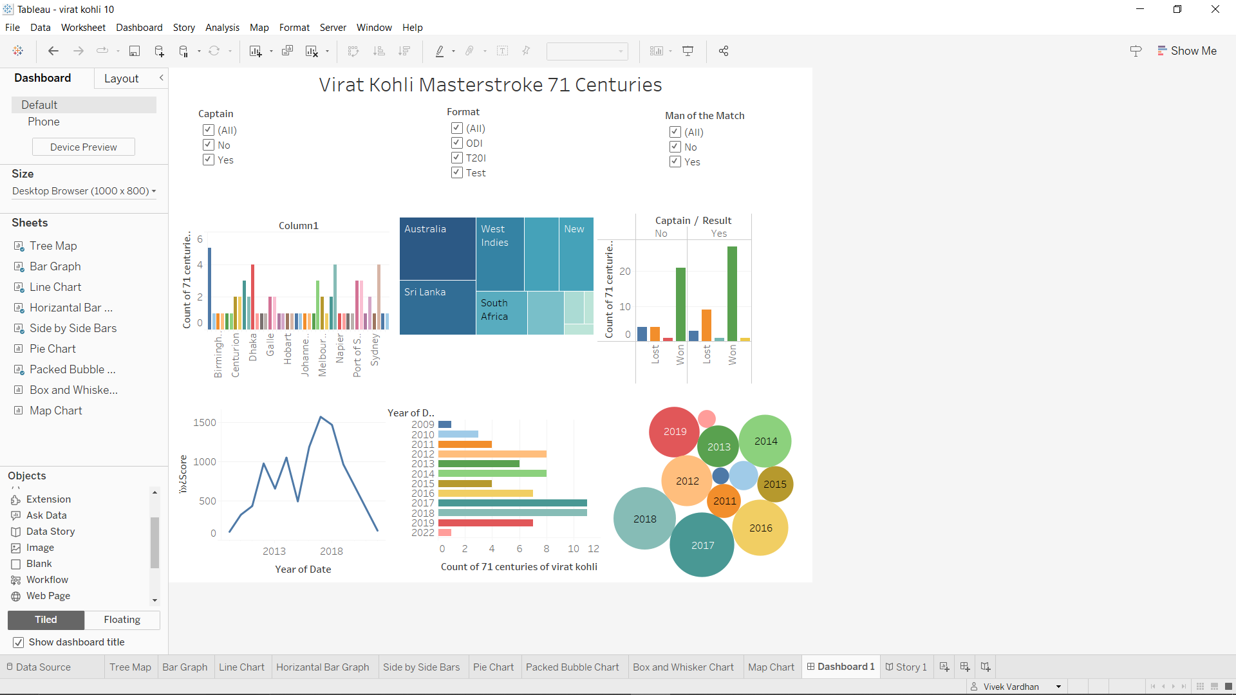

# Milestone 6: Story

A data story is a method of conveying data and analysis through a narrative structure, aimed at enhancing engagement and facilitating comprehension. Typically, a data story comprises a well-defined introduction to provide context and background for the data, a structured body that systematically presents the data and analysis, and a concluding section that encapsulates key insights and their significance. Data stories can take various forms, including reports, presentations, interactive visualizations, and videos, making data communication more versatile and effective."Activity:1- No of Scenes of Story

# **<https://drive.google.com/file/d/1xUCV1GkLxODdi6Io1YEF-UoJEHwdc313/view?usp=sharing>**

# Milestone 7: Performance Testing

Performance testing for Tableau entails the evaluation of the software's responsiveness and scalability, including its underlying infrastructure. This evaluation is centered around assessing how Tableau functions in various scenarios, including its capabilities with large datasets, intricate visualizations, simultaneous user access, and resource-intensive data queries. Through performance testing, organizations can verify that Tableau consistently provides top-tier performance, responsiveness, and reliability. This, in turn, empowers users to analyze and visualize data efficiently and effectively.

**Activity 1: Amount of Data Rendered to DB**

* The amount of data that is rendered to a database depends on the size of the dataset and the capacity of the database to store and retrieve data.
* Open the MySQL Workbench, go to the database then click to expand the tables, select the table and click on (i) button to get the information related to table such as column count, table rows etc.

# No of Calculated Fields:

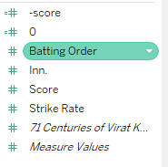

**Milestone 8: Web integration**

Publishing helps us to track and monitor key performance metrics, to communicate results and progress. help a publisher stay informed, make better decisions, and communicate their performance to others.

**Publishing dashboard and reports to tableau public**

Step 1: Go to Dashboard/story, click on share button on the top ribbon

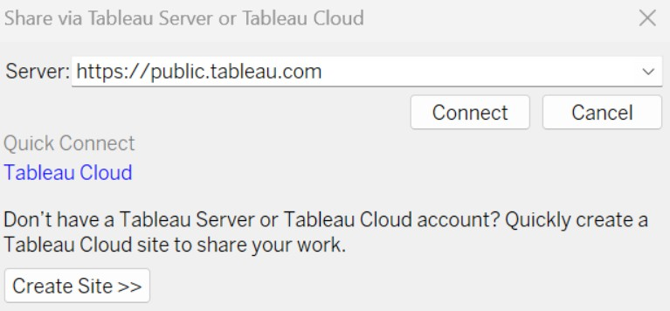

Give the server address of your tableau public account and click on connect.

**Step 2:** Once you click on connect it will ask you for tableau public user name and password

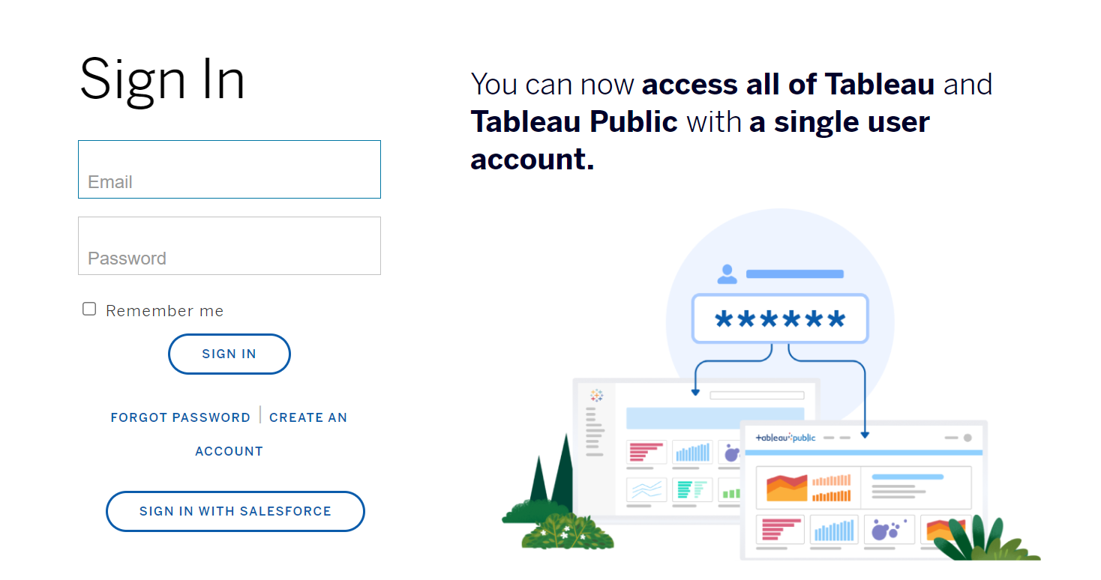

Once you login into your tableau public using the credentials, the particular visualization will be published into tableau public

**Note: While publishing the visualization to the public, the respective sheet will get published when you click on share option.**

**Home page:-**

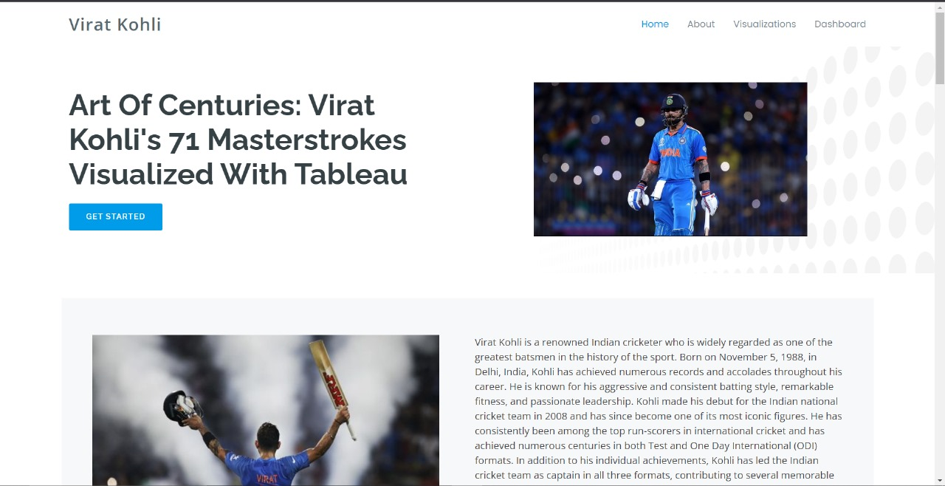

**About page:**

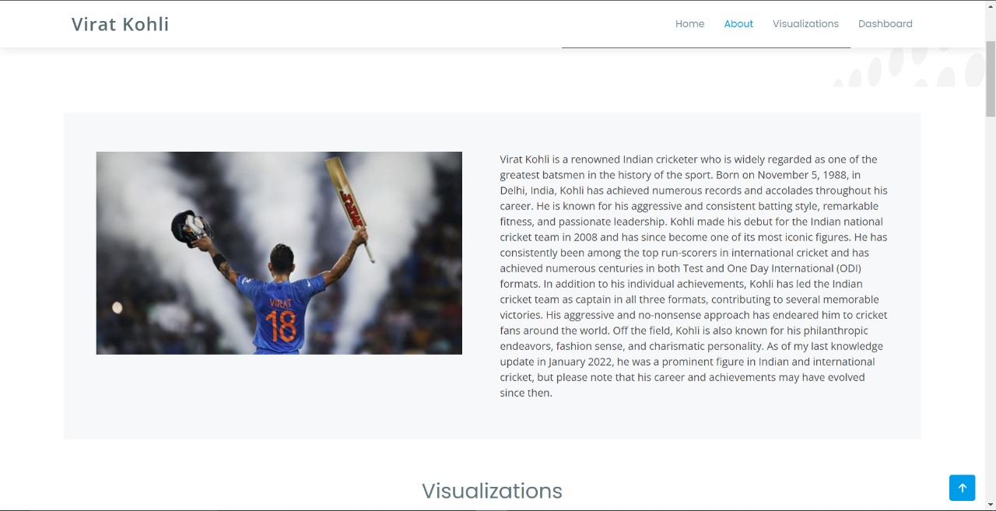

**Visualization page:-**

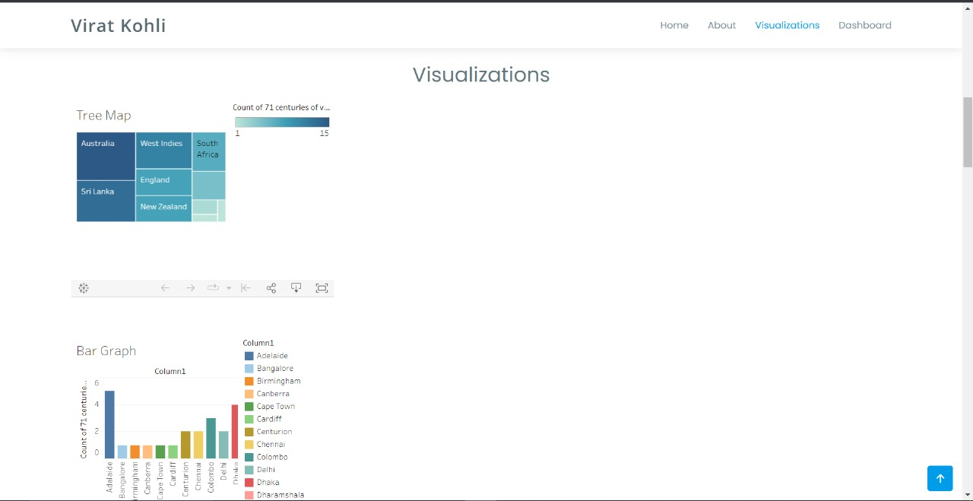 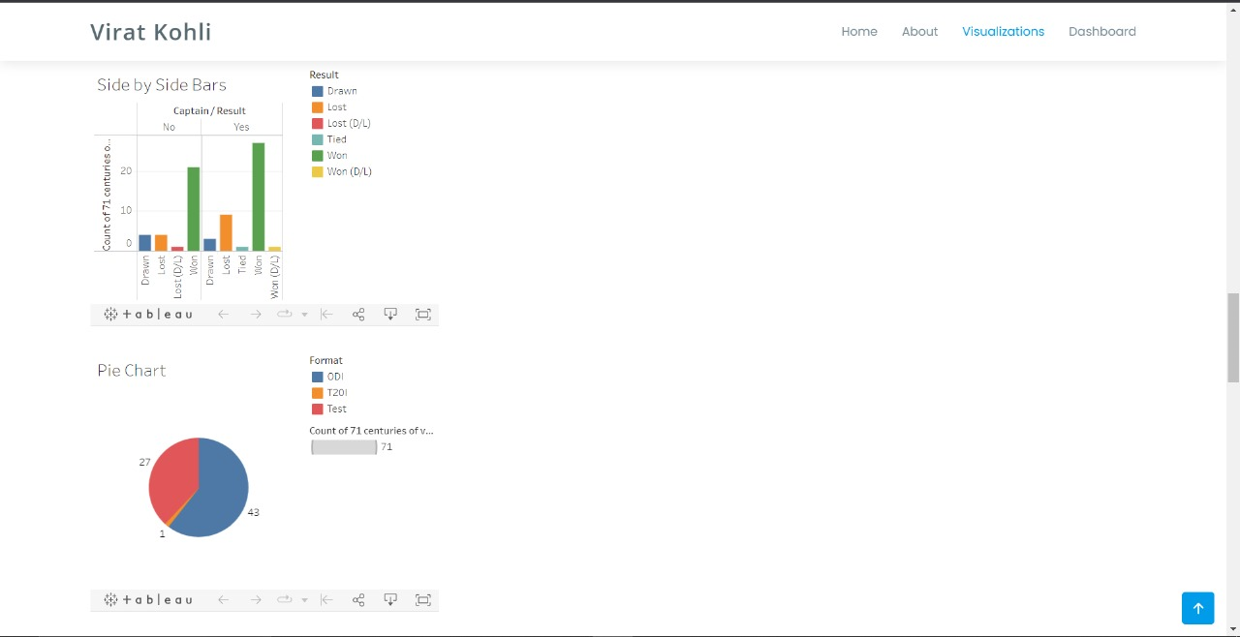

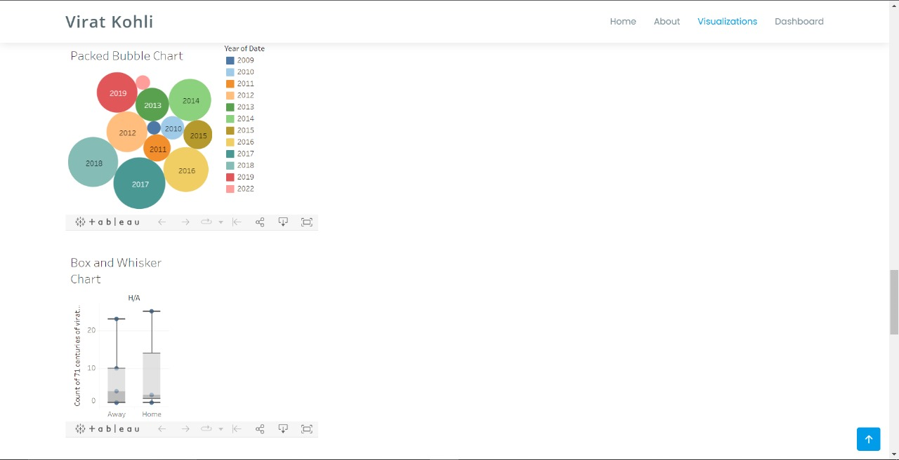

**Dashboard page:**

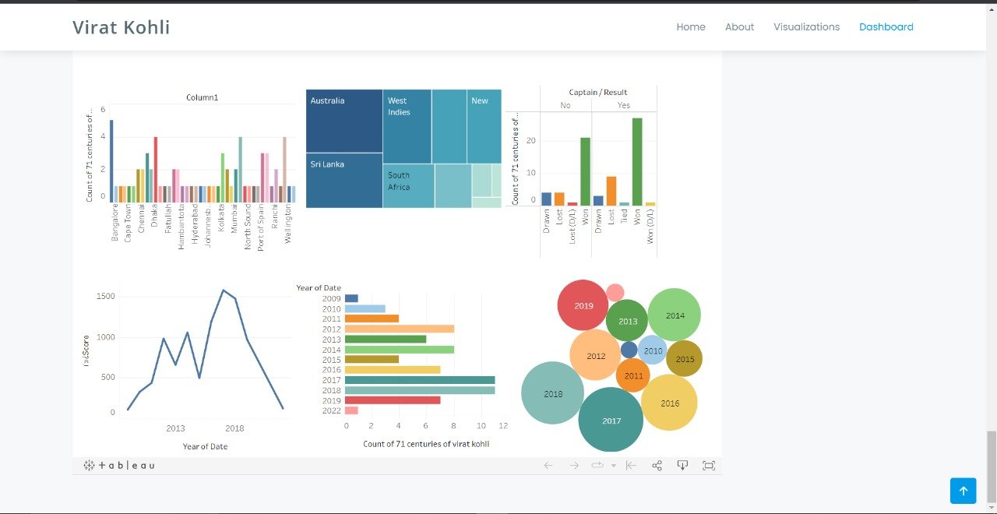

# Milestone 9: Project Demonstration & Documentation

https://drive.google.com/file/d/1lAdRqMtNjfQxSPYGhA_94SAI1c3jmQOI/view?usp=sharing